ENGR 101 Fall 2018

Service Project Design Report Instructions

The purpose of the design report is to communicate your design process and your result. It should clearly describe each part of the engineering design process as it relates to your project and convey how the final design was the best choice to meet the problem statement. The report should contain all the sections described in this document.

**Additionally, each report should meet the following requirements:**

* All pages numbered at bottom of each page. Page numbering begins with the Abstract, but often the number “1” is not shown on the first page. Instead, the number “2” would appear on the page following. The title page does not count as page number “1”. <https://www.youtube.com/watch?v=JDqPR98mIZM>
* Use Microsoft “Styles” to organize your report title, headings, and text font, size, and spacing. When this is set up, you can make a change to the style definition and it will automatically update the text in your report. Many reports are structured in an outline style. This numbering style can be controlled by making appropriate settings in the “Bullets and Numbering” menu selection. <https://www.youtube.com/watch?v=w2lES-5Ynbk>
* Double space all text.
* Maintain consistent 1” margins around each page (also true for figures, tables, and appendices).
* Properly label Figures and Tables. (see below)
* Always have a line of text or short paragraph between headings.

**Figures and Tables**

Figures and tables are a very important part of reports. Often, your busy boss or coworkers will not even read the text, but simply scan the figures to get the point of your report. Therefore, the figures must be self-explanatory. Please follow these guidelines in preparing figures and tables.

When using figures and tables:

1. Every figure or table should be referenced in the text *before* the figure or table appears (e.g. “…as shown in Figure 3”)
2. Figures and tables should be placed within the text (however, large tables of data or program listings should be placed in appendices – also with some reference in the text as to their location)
3. Tables and figures must be numbered and titled (e.g. “Figure 3. Box Dimensions”) with the title above tables and below figures
4. If you cannot call it a table, call it a *figure* – nothing else. (no photo 1)

**1. Numbers:**

Every table or figure needs a number. Generally, graphs, flow sheets, photographs, etc., are all numbered consecutively as Figure 1, Figure 2, etc. Tables are numbered separately, as Table 1, Table 2, etc.

Somewhere in the text of a written report, you should refer to *each and every* figure and table that you include, by number. This reference would be an explanation of the main point of the figure or table (why it has been included in the document). Generally, you include a figure or table to support an argument or offer an explanation, just as you might use a footnote referencing a book. This standard can help you know where to include the reference in the text. Figures or tables in an appendix are by definition supplementary, and so do not necessarily need to be referenced in the main text. However, they should still be self-explanatory.

**2. Captions:**

Every figure and table need one. It should begin with the number (e.g. “Figure 1.”) and then include a title that conveys the *importance* of the data. Why is this being included in your report; what useful information does it provide? Also, include any information needed to allow the figure or table to stand alone (source of data, etc.). A standard format is to write the caption directly *below* figures and directly *above* tables. Note that Excel asks for a title when you create a chart, and then automatically displays this above the graph. In general, you may ignore this (leave it blank) since a well-written caption serves as the title.

**3. Graphs:**

**a. Axes**

* When making x-y plots, make sure that the abscissa (x) is always the independent variable while the ordinate (y) is always the dependent variable. If told to plot A as a function of B, you should therefore put A (dependent) on the y-axis and B (independent) on the x-axis.
* Always label the axes, including units.
* Be aware that the default axis settings from a software package like Excel may not always be best. Choose values for the limits and increments on each axis so that the graph is easy to read, and there is a minimum of unused space. You may need to reformat the way the axis number labels are displayed, to make them more readable.

b. **Legend:**

You need one if (and only if) you have different kinds of data on the same plot, with different symbols to distinguish them. Alternatively, this data can be distinguished in the text of the caption, and the legend left off.

c. **Lines and Data Points:**

Data points are just that – points. Lines or curves should be present only if they illustrate an equation that you are attempting to fit to the data. Do not use the “connect-the-dots” plot in Excel unless you have a good reason for it.

**4. Printing:**

When you print a chart that was created with software, be sure the print is a reasonable, legible size. This means you may need to resize the chart manually before printing. If there are colors used on the graph (*e.g.* to distinguish different types of data), be sure the black-and-white print can be understood. When you copy and paste a chart/graph into your report, make sure that all text is legible with no fuzziness.

Project Report Title

Team #

Names of Team Members

Date of Final Printing

Engineering 101ABCDE

Professor’s Name

***********************page separator – omitted to save paper for this printout, in the real report there should be a page break here*********************************

**Abstract**

An abstract is not an introduction. In an abstract, you should summarize your entire report including your results. This can include some introduction, a list of key design issues, and a summary of your final design. Usually, the abstract is no more than 6-8 sentences or 1-2 short paragraphs and can often be completed in 3-4 sentences. It may be similar to the submittal memo text, but focuses on the report, rather than additional activities.

*****************page separator ************************************************

# Introduction

In the introduction section of the report, you should present any background information necessary for a reader with a similar background to yourself, but someone who is not familiar with the project. You should also mention what the overall goals of the project are and why it is important. Remember that this report is primarily aimed towards informing the client (not primarily the instructor).

# Problem Statement

In this section, you should discuss the requirements for the project as provided by your client. If you have more than one subsection, include a paragraph like this one to summarize the subsections. If this section is fairly short or if your style lends itself to merging the following subsections together, then omit the subsections. However, make appropriate use of paragraphs to organize your message.

## Detailed Design Specifications

In this section you should provide detailed design specifications including all functions, objectives, and constraints for your project either from your client or research. Do not your design solution.

## Project Plan

Discuss the timetable for your project. Include the team’s Gantt Chart as a properly labeled figure in this section. It you can’t print it well to include here, you may insert it with your appendix.

# Project Design

In this section you will present your design process. Your goal should be to clearly articulate the steps of the design process that you have followed and then to communicate why you chose the design you did. It is important to discuss some legitimate alternatives to your final design, but then give valid reasons for not using them.

## Design Alternatives (possible solutions)

Present all *significant* alternatives in this section. You do not need detailed (dimensioned) drawings for each, but if a sketch would help to communicate the idea, include it. Again, make sure you properly incorporate your figures into the text. Discuss how you decided which possible solution to use and reference or include your decision matrix in this section to help defend your design choice. Make sure the reader knows why you didn’t choose certain alternatives and instead moved forward with your selected design.

## Final Design

Present your final design. This is the design that you are recommending to your client that incorporates all of your testing and redesigning. Be sure to include explanations of both what you chose and why you chose it. Describe the size, shape, and material, and explain how the user would use it. Remember, your client should be convinced that this design will work and have enough information to create the design. Discuss why this was the best approach (unless fully discussed in the previous section).

### Bill of Materials and Budget

Include a detailed list of materials and quantities and a corresponding budget for the cost of materials. This should include all materials that someone would need to purchase or have in order to create your final design for use. (So include all wood, even if you didn’t have to buy it; include paint or final treatment, even if you didn’t use that in your prototype.) In addition, add an estimate on a budget for time to build your design.

### CAD Design

Make sure your final design description is detailed and complete, with dimensions. Include different drawing views to ensure a good representation of the design. Someone should be able to duplicate your prototype or construct your final design based only on the contents of you report.

One note on AutoCAD drawings: cut and paste from AutoCAD into Word (and add a note that says it is “Not to scale.” Avoid the temptation to print from AutoCAD and just attach the sheet to your report. Usually the margins are incorrect and the figure is poorly integrated into the rest of the report. The location of electronic files used for virtual prototyping (accessible to the instructor) should be included in the report.

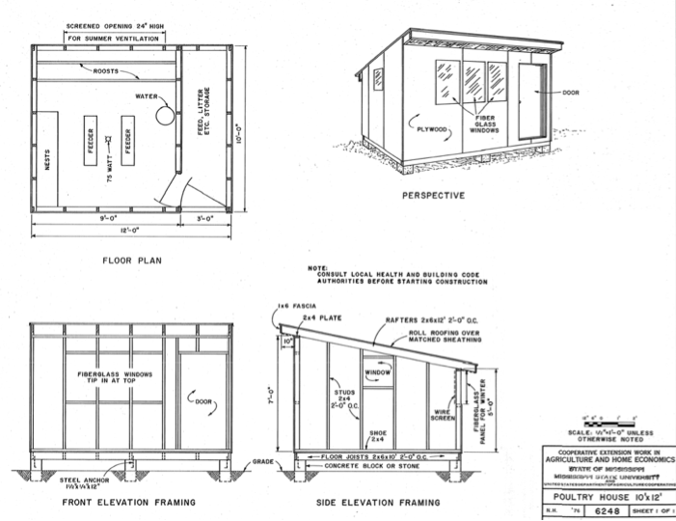

Figure 3.1. Example CAD drawings showing adequate detail to construct the project. (Source: <http://msucares.com/pubs/plans/6248.pdf>)

### Prototype Construction

In this section, you step back in time a little and present your prototype. This is different than your final design, but this give the reader more insight as to how you arrived at your final design. Be sure to include explanations of both what was prototyped and why. You may have made several prototypes or tested different components. Describe each iteration of your project as it moved from your selected design choice to become the final design. Include at least one color picture of your prototype.

### Testing Summary:

Describe the test parameters and the rational for testing these parameters.

Present the testing data and analysis with respect to the test objective. Explain how the testing and results relate to the design specs and influenced your final design. Include your decision and rational on a path forward as a conclusion of your tests (keep design as is, make a design change, make a spec change or make a test parameter change).

# Conclusion

Summarize what you accomplished with this project, how the client will benefit, and how it met the goals of the project. Suggest additional work as a follow-up to what you have completed.

*****************page separator ****************

**References**

Include a list of references used in this project. This should include any text-based or electronic information along with any interview with persons who provided assistance.

*****************page separator****************

**Appendices**

Use an appendix title page (with an optional appendix table of contents) to separate the report body from any large tables of data or sets of drawings which are included in the appendix. The pages in the appendix should all be numbered and Appendix A should be clearly distinguished from Appendix B, etc. All tables and figures should have titles and numbers like those used in figures and tables in the body of the paper, but would probably be prefixed with the appendix number (e.g. Figure A1….). An appendix is not a dumping ground for miscellaneous sketches or rough computations. For this project, you may not need to include any appendices.

*******************page separator – done to save paper for this printout****************

Appendices begin here.